“LibroTrack: Bookstore and Stationery Shop Management System”



In Partial Fulfilment of the Requirements of the Courses:
IT112 – Advanced Database System & IT113 – Event Driven Programming

Ancog III, Saturnino
Ilajas, Ace Romel
Lenterna, Cleentson Dewey
Moleta, Idyll Claire
Orilla, Aljune

John Louis Mercaral, MIS
Courses Instructor

December 2025
Table of Contents
I. PROBLEM STATEMENT 1
II. LOGICAL DESIGN 2
Requirements Analysis 2
Entities: 2
Attributes: 2
Relationship & Cardinality: 4
Data Model (ER Diagram): 5
III. PHYSICAL DESIGN 7
SQL Queries: 7
API: 11
IV. Ecommerce: 12
Features: 12
Objectives: 12
Scope and Limitation: 13
Reference 14

- PROBLEM STATEMENT
In today’s digital age, online shopping has become the most vital part of modern consumer behavior. However, many businesses still relying on traditional selling methods, which limit their market reach. Customers now expect convenience, instant access to product , and secure digital payment options that physical stores cannot always provide. This gap between customer expectations and business capabilities leads to inefficiency and lost opportunities for both parties. Studies show that the slow adoption of e-commerce among businesses is mainly to a lack of digital infrastructure, technical knowledge, and high costs [1].
To conquer these challenges, the proposed project will develop a user-friendly E-Commerce System designed to help businesses sell products online efficiently. The system will include key features such as product browsing, shopping cart functionality and order tracking to improve customer satisfaction. On the admin side it will allow business owners to manage inventory. By providing these, the system aims to simplify business operations. This solution will bridge the gap between traditional and digital commerce, making it easier for businesses to compete in the online marketplace.
This project aims to inspire small businesses to fully embrace e-commerce and benefit from the growing digital economy. Through the automation of inventory order. Business processes can become faster. Customers on the other hand will enjoy a more convenient and reliable online shopping experience. Furthermore, research highlights that e-commerce adoption improves overall business performance, customer reach [2]. Therefore, the implementation of this proposed E-Commerce System will serve as a practical solution to promote business growth and digital transformation in the modern market.

LOGICAL DESIGN

Requirements Analysis
The bookstore and stationery shop currently face challenges in managing their sales inventory and customer transactions efficiently. The absence of a centralized automated system results in difficulties tracking product availability processing customer orders and managing supplier information. Manual processes often lead to human errors such as incorrect pricing inaccurate stock counts and delays in order fulfillment. Moreover the lack of real-time sales monitoring and analytics makes it difficult for management to make informed decisions regarding product restocking and marketing strategies. Based on the principles of database normalization, this study explores the requirements analysis for the LibroTrack E-commerce Bookstore and Stationery Shop Management System, identifying its entities attributes and cardinalities to ensure data consistency minimize redundancy and improve overall operational efficiency.

Entities:
- Users:Represents the admin and customer.
- Products:Represents the items.
- Cart: Represent the collection of items that is added by the customer.
- Orders:Represents the items purchased.
- Order_Details: Contains specific information about each item included in a customer’s order (e.g. product ID, quantity, price).
- Inventory_Log:Records all inventory movements or changes such as items added to cart and sold.

Attributes:
1. Users
- User_ID (PK):Unique identifier for each user in the system.
- Full_Name: The complete name of the user.
- Email: The user email address used for communication or login.
- Username: The name chosen by the user to log in to the system.
- Password: A secret code used to secure the user account.
- Role (Customer, Admin, Staff): Defines the user access level or position in the system.
- Contact_Number: The user’s phone number for contact purposes.
- Address: The user’s residential or delivery address.

2. Products
- Product_ID (PK): Unique identifier for each product in the inventory.
- Product_Name: The name or title of the product.
- Category (Book, Stationery, Notebook, Pen, etc.): The classification or type of product.
- Description: Brief details or features of the product.
- Author/Brand (for books/stationery): The author (for books) or brand/manufacturer (for stationery).
- Price: The selling price of the product.
- Stock_Quantity: The number of available units in inventory.
- Supplier_ID (FK): References the supplier who provides the product.

3. Cart
- Cart_ID (PK):Unique identifier for each shopping cart.
- User ID (FK):References the user who owns or created the cart.
- Product_ID(FK):Reference the product.

4. Orders
- Order_ID (PK):Unique identifier for each customer order.
- User_ID (FK ): References the customer who placed the order.
- Order_Date:The date when the order was placed.
- Total_Amount:The total cost of all items in the order.
- Order_Status (Pending, Processing, Shipped, Completed, Cancelled):Indicates the current stage or condition of the order.

5. Order_Details
- OrderDetail_ID (PK):Unique identifier for each order detail record.
- Order_ID (FK):References the order to which the product belongs.
- Product_ID (FK):References the specific product included in the order.
- Quantity:The number of units of the product ordered.
- Subtotal:The total price for the product (Quantity × Product Price).

6. Inventory_Log
- Log_ID (PK):Unique identifier for each inventory log entry.
- Product_ID (FK):References the product affected by the inventory change.
- Date:The date when the inventory change occurred.
- Change_Type (Stock In, Stock Out, Sale):Specifies the type of inventory movement or transaction.
- Quantity_Changed:The number of product units added or removed.
- Remarks:Additional notes or details about the inventory update.

Relationship & Cardinality:
- Users → Orders: One user (customer) can place many orders (1:M).
- Orders → Order_Details: One order can contain many products (1:M).
- Products → Order_Details: One product can appear in many orders
(M:M through Order_Details).
- Cart → Products: One cart can add many products (1:M).
- Products → Inventory_Log: One product can have many inventory logs (1:M).

Data Model (ER Diagram):
- Crow’s Foot

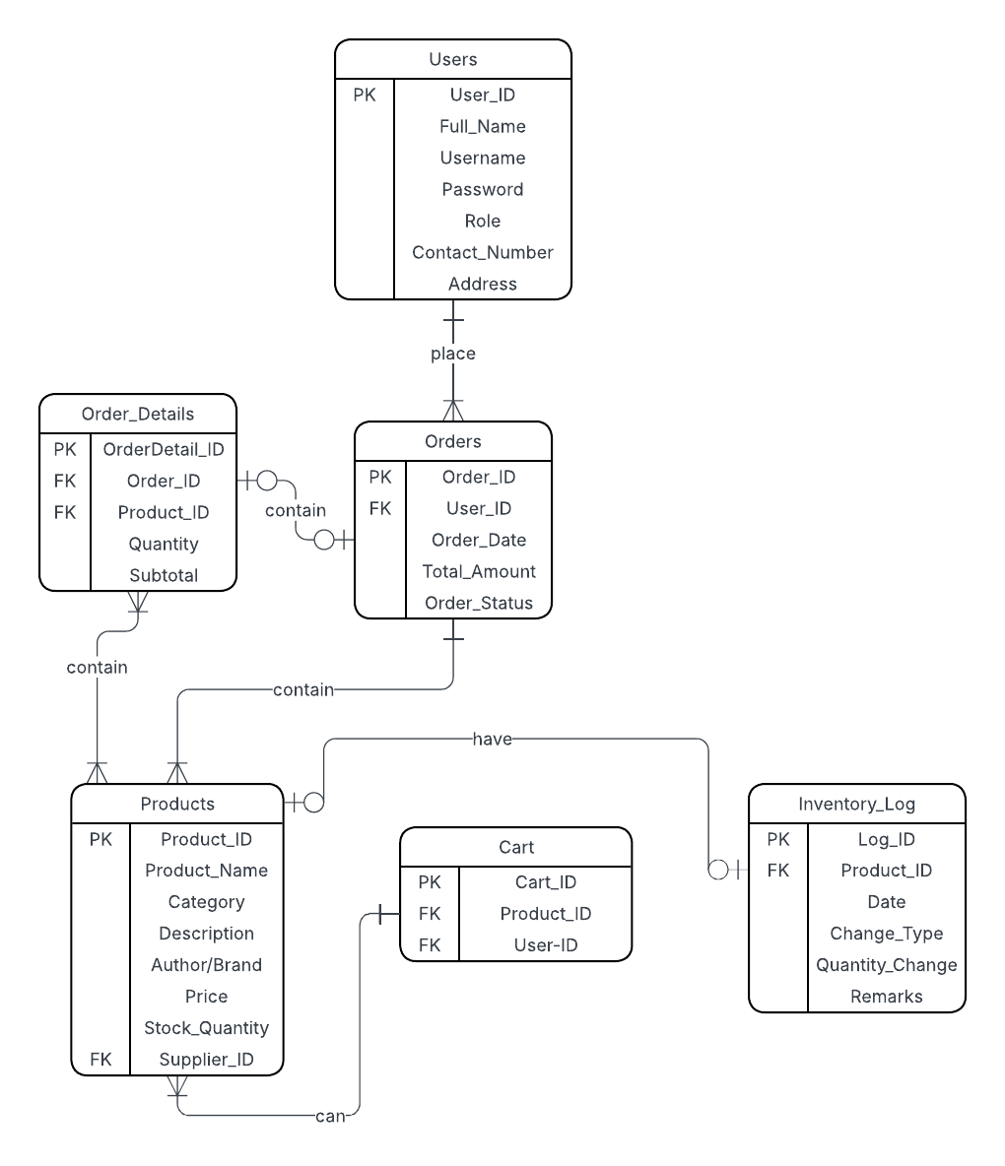

- Chen Notation

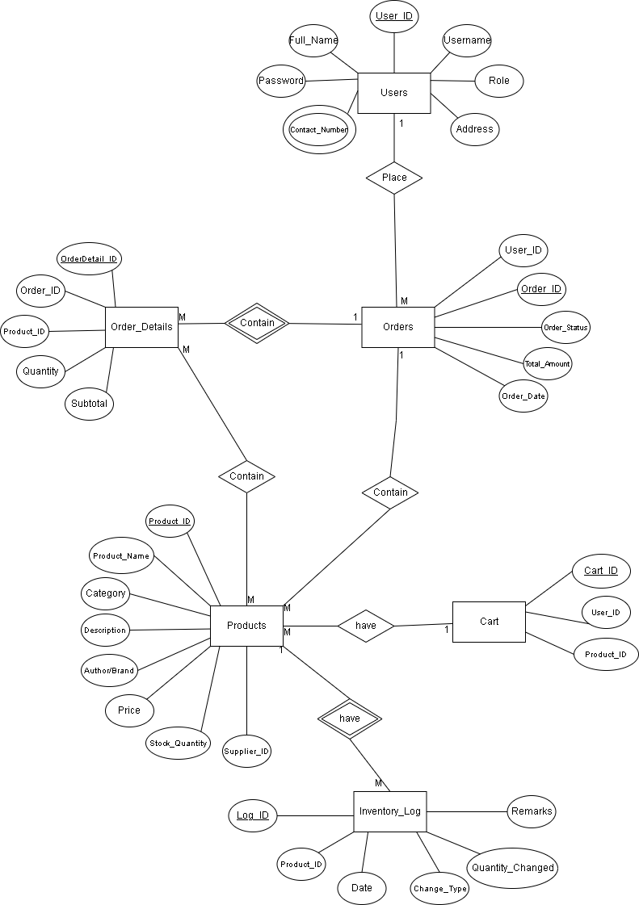

PHYSICAL DESIGN

SQL Queries:
Create tables
CREATE TABLE Users (
User_ID INT AUTO_INCREMENT PRIMARY KEY,
Full_Name VARCHAR(100) NOT NULL,
Email VARCHAR(100) UNIQUE NOT NULL,
Username VARCHAR(50) UNIQUE NOT NULL,
Password VARCHAR(255) NOT NULL,
Role ENUM('Customer', 'Admin', 'Staff') DEFAULT 'Customer',
Contact_Number VARCHAR(20),
Address TEXT
);

CREATE TABLE Products (
Product_ID INT AUTO_INCREMENT PRIMARY KEY,
Product_Name VARCHAR(150) NOT NULL,
Category ENUM('Book', 'Stationery', 'Notebook', 'Pen', 'Other') DEFAULT 'Other',
Description TEXT,
Author_Brand VARCHAR(100),
Price DECIMAL(10,2) NOT NULL,
Stock_Quantity INT DEFAULT 0
);

CREATE TABLE Cart (
Cart_ID INT AUTO_INCREMENT PRIMARY KEY,
User_ID INT NOT NULL,
Product_ID INT NOT NULL,
FOREIGN KEY (User_ID) REFERENCES Users(User_ID) ON UPDATE CASCADE ON DELETE CASCADE,
FOREIGN KEY (Product_ID) REFERENCES Products(Product_ID) ON UPDATE CASCADE ON DELETE CASCADE
);

CREATE TABLE Orders (
Order_ID INT AUTO_INCREMENT PRIMARY KEY,
User_ID INT NOT NULL,
Order_Date DATETIME DEFAULT CURRENT_TIMESTAMP,
Total_Amount DECIMAL(10,2) DEFAULT 0.00,
Order_Status ENUM('Pending', 'Processing', 'Shipped', 'Completed', 'Cancelled') DEFAULT 'Pending',
FOREIGN KEY (User_ID) REFERENCES Users(User_ID) ON UPDATE CASCADE ON DELETE CASCADE
);

CREATE TABLE Order_Details (
OrderDetail_ID INT AUTO_INCREMENT PRIMARY KEY,
Order_ID INT NOT NULL,
Product_ID INT NOT NULL,
Quantity INT NOT NULL,
Subtotal DECIMAL(10,2) NOT NULL,
FOREIGN KEY (Order_ID) REFERENCES Orders(Order_ID) ON UPDATE CASCADE ON DELETE CASCADE,
FOREIGN KEY (Product_ID) REFERENCES Products(Product_ID) ON UPDATE CASCADE ON DELETE CASCADE
);

CREATE TABLE Inventory_Log (
Log_ID INT AUTO_INCREMENT PRIMARY KEY,
Product_ID INT NOT NULL,
Log_Date DATETIME DEFAULT CURRENT_TIMESTAMP,
Change_Type ENUM('Stock In', 'Stock Out', 'Sale') NOT NULL,
Quantity_Changed INT NOT NULL,
Remarks TEXT,
FOREIGN KEY (Product_ID) REFERENCES Products(Product_ID) ON UPDATE CASCADE ON DELETE CASCADE
);
Insert sample data into tables
INSERT INTO Users (Full_Name, Email, Username, Password, Role, Contact_Number, Address)
VALUES ('Juan Dela Cruz', 'juan@example.com', 'juanDC', 'password123', 'Customer', '09171234567', 'Davao City');

INSERT INTO Products (Product_Name, Category, Description, Author_Brand, Price, Stock_Quantity)
VALUES
('Gel Pen Set', 'Pen', 'Smooth writing gel pens', 'Pilot', 199.00, 50),
('Notebook A5', 'Notebook', 'A5 size ruled notebook', 'StarPaper', 79.00, 100);

INSERT INTO Orders (User_ID, Total_Amount, Order_Status)
SELECT User_ID, 99.00, 'Pending' FROM Users WHERE Username = 'juanDC';

Update existing data
UPDATE Users
SET Contact_Number = '09987654321', Address = 'Iloilo City'
WHERE User_ID = 1;

UPDATE Products
SET Price = 549.99, Stock_Quantity = 25
WHERE Product_Name = 'The Great Gatsby';
UPDATE Orders
SET Order_Status = 'Cancelled'
WHERE User_ID = 3;
Delete data
DELETE FROM Users
WHERE User_ID = 3;

DELETE FROM Products
WHERE Category = 'Other';

TRUNCATE TABLE Orders;
Select data
-- Retrieve all users who are Customers.
SELECT User_ID, Full_Name, Role, Address
FROM Users
WHERE Role = 'Customer';

-- Retrieve the total purchase amount of each user.
SELECT User_ID, SUM(Total_Amount) AS Total_Spent
FROM Orders
GROUP BY User_ID;

-- Retrieve how many orders exist in each status (Pending, Completed, etc.).
SELECT Order_Status, COUNT(Order_ID) AS Total_Orders
FROM Orders
GROUP BY Order_Status;
-- Retrieve the average price per product category (Books, Stationery, etc.).
SELECT Category, AVG(Price) AS Average_Price
FROM Products
GROUP BY Category;
--Retrieve the product with the highest price
SELECT Product_Name, MAX(Price) AS Highest_Price
FROM Products;
Join tables
-- Retrieve only users who have placed orders — it matches records from both tables where User_ID is the same.
SELECT
Users.Full_Name,
Orders.Order_ID,
Orders.Order_Date,
Orders.Total_Amount
FROM Users
INNER JOIN Orders ON Users.User_ID = Orders.User_ID;
-- Retrieve all users, including those who haven’t made any orders yet (their order columns will appear as NULL).
SELECT
Users.Full_Name,
Orders.Order_ID,
Orders.Order_Status
FROM Users
LEFT JOIN Orders ON Users.User_ID = Orders.User_ID;
-- Retrieve all orders, even if the user was deleted from the Users table.
SELECT
Orders.Order_ID,
Users.Full_Name,
Orders.Total_Amount
FROM Users
RIGHT JOIN Orders ON Users.User_ID = Orders.User_ID;

Ecommerce:

Features:
- User Authentication – secure login and registration for customers and administrators.
- Product Catalog – online browsing of books and stationery items with search and filter options.
- Shopping Cart – customers can add items to cart.
- Inventory Management – stock levels automatically adjust when order are made.
- Responsive Design – accessible via desktop, tablet and mobile.

Objectives:
General Objective

- To design and develop a web-based e-commerce system for bookstores and stationery shops that enables online product browsing.

Specific Objectives

- To create a web-based shop for books and Stationery where customers can browse, search products online.
- To implement inventory management that updates stock levels in real-time after orders.
- To provide administrative tools for managing products and order reports.
- To ensure data security and protect customer information through authentication and encryption.

Scope and Limitation:
Scope

- The system allows customers to register, log in and shop online for books and stationery.
- Customers can search, filter and order products through a responsive web interface.
- Admin can manage products, inventory, suppliers and orders via a web dashboard.

Limitations

- The system does not include physical logistics/delivery services order delivery depends on third-party couriers.
- It does not include advanced recommendation engines (e.g. AI-based product suggestions).
- The system focuses on bookstore and stationery products only not other retail goods.
- The system requires a stable internet connection to access features since it is web-based.
- Customer support features such as live chat are not included unless integrated later.

Reference
[1] A. Sharma and R. Sheth, “E-commerce and its impact on business strategy,” International Journal of Business and Management Invention, vol. 8, no. 3, pp. 45–50, 2019.
[2] P. Chaffey, Digital Business and E-Commerce Management, 7th ed., Pearson Education Limited, 2019.

